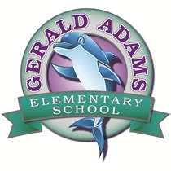

SAC Agenda 1/24/19/

8:00am in the Media Center

1. Meeting Call to Order
2. Adoption of Agenda
3. Introduction & Welcome
4. New Business

⦁Student Performance Data

⦁PBS Data and upcoming events

1. Calendar Updates
2. Transitioning into the new building-update
3. New drop off and pick up, new bus loop
4. Open Agenda
5. Next Meeting Confirmation / Adjournment

**Chairman Notes:** Discuss plans for Open House of new school, encourage attendance and participation in SAC

**At Gerald Adams Elementary, we are committed to working to collaboratively provide a quality learning environment in which ALL children can learn and develop to their maximum potential.**